HANOI UNIVERSITY OF SCIENCE AND TECHNOLOGY

School of Information and communications technology

Subsystem Design Document

AIMS – An Internet Media Store

ITSS Software Development

Nguyen Trong Huy

Huy.NT210451@sis.hust.edu.vn

*Hanoi,* *March 2024*

Table of contents

Table of contents 1

1 Introduction 2

2 Subsystem Class Diagram 3

3 Class Diagram Specification 4

3.1 Class “IPayment” 4

3.2 Class “VNPaySubsystemController” 4

3.3 Class “VNPayBoundary” 5

3.4 Class “SandBoxBoundary” 5

3.5 Class “PayOrderException” 5

3.6 Class “OtherErrorTransactionException 6

3.7 Class “SuspiciousTransactionException” 6

3.8 Class “IncompleteTransactionException” 7

3.9 Class “BankMaintainanceException” 7

# Introduction

This subsystem design document serves as a comprehensive guide outlining the detailed design of interface of system. In this case, we design the system interface for interaction between AIMS and VNPay under the use case “Place Order”.

# Subsystem Class Diagram

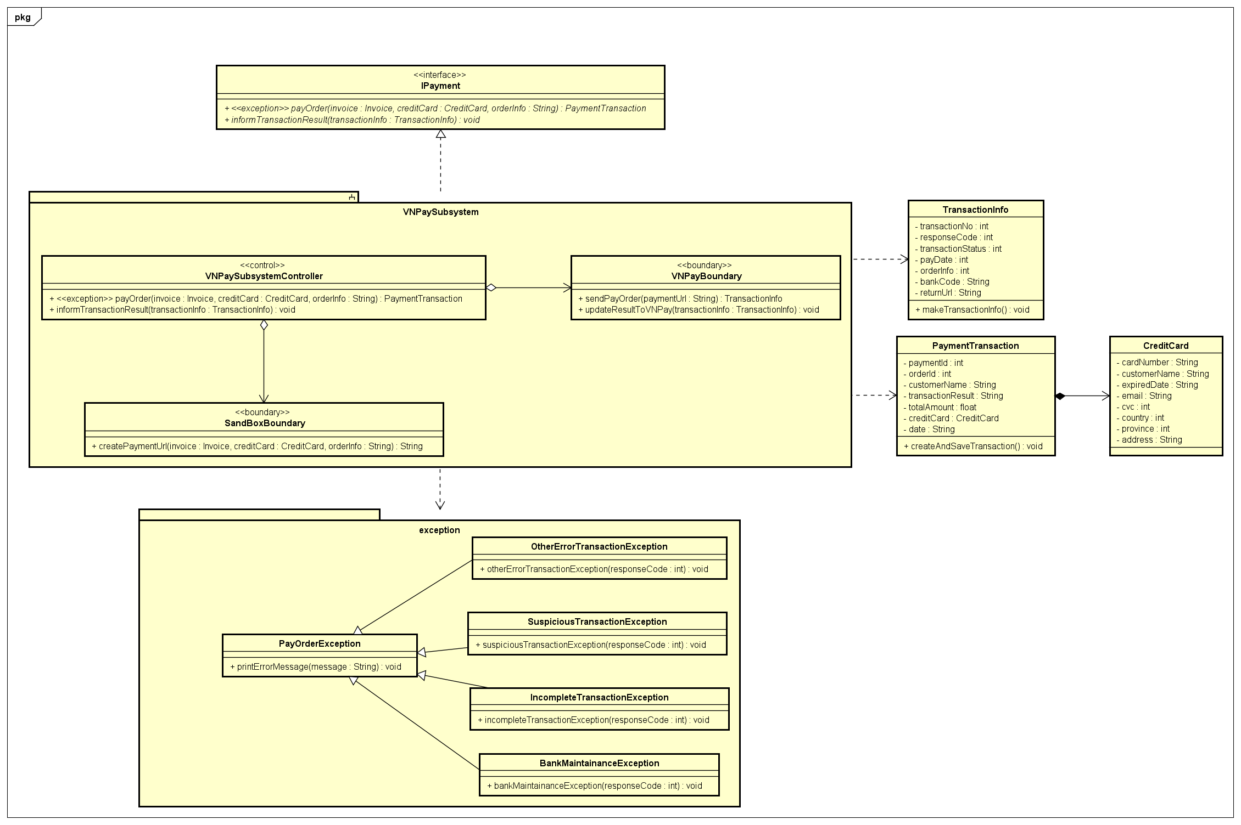

# Class Diagram Specification

## Class “IPayment”

|  |  |  |  |  |
| --- | --- | --- | --- | --- |
| **Name** | IPayment <<Interface>> | | | |
| **Description** | Blueprint for payment stage of the system | | | |
| **Visibility** | Public | | | |
| **Attribute** | None | | | |
| **Operation** | **Name** | **Type** | **Visibility** | **Description** |
| payOrder | PaymentTransaction | Default | responsible for pay the order |
| informTransactionResult | void | Default | responsible for informing result of transaction. |
| **Operation**  **parameters** | **Operation name** | **Name** | **Type** | **Description** |
| payOrder | invoice | Invoice | Invoices need to be paid |
| creditCard | CreditCard | Credit Card of customers |
| orderInfo | String | Payment content |
| informTransactionInfo | transactionInfo | TransactionInfo | Information of transaction |

## Class “VNPaySubsystemController”

|  |  |  |  |  |
| --- | --- | --- | --- | --- |
| **Name** | VNPaySubsystemController | | | |
| **Description** | Payment stage of the system | | | |
| **Visibility** | Default | | | |
| **Attribute** | None | | | |
| **Operation** | **Name** | **Type** | **Visibility** | **Description** |
| payOrder | PaymentTransaction | Default | responsible for pay the order |
| **Operation**  **parameters** | **Operation name** | **Name** | **Type** | **Description** |
| payOrder | invoice | Invoice | Invoices need to be paid |
| creditCard | CreditCard | Credit Card of customers |
| orderInfo | String | Payment content |
| informTransactionInfo | transactionInfo | TransactionInfo | Information of transaction |

## Class “VNPayBoundary”

|  |  |  |  |  |
| --- | --- | --- | --- | --- |
| **Name** | VNPayBoundary | | | |
| **Description** | Responsible to connect with VNPay | | | |
| **Visibility** | Default | | | |
| **Attribute** | None | | | |
| **Operation** | **Name** | **Type** | **Visibility** | **Description** |
| sendPayOrder | TransactionInfo | Default | responsible for send payment request to VNPay |
| updateResultToVNPay | void | Default | responsible for update result back to VNPay |
| **Operation**  **parameters** | **Operation name** | **Name** | **Type** | **Description** |
| sendPayOrder | paymentUrl | String | Payment Url |
| updateResultToVNPay | transactionInfo | TransactionInfo | Transaction Information |

## Class “SandBoxBoundary”

|  |  |  |  |  |
| --- | --- | --- | --- | --- |
| **Name** | SandBoxBoundary | | | |
| **Description** | Responsible to connect with Sandbox to create Url for payment | | | |
| **Visibility** | Default | | | |
| **Attribute** | None | | | |
| **Operation** | **Name** | **Type** | **Visibility** | **Description** |
| createPaymentUrl | String | Default | responsible for creating url |
| **Operation**  **parameters** | **Operation name** | **Name** | **Type** | **Description** |
| createPaymentUrl | invoice | Invoice | Invoices need to be paid |
| creditCard | CreditCard | Credit Card of customers |
| orderInfo | String | Payment content |

## Class “PayOrderException”

|  |  |  |  |  |
| --- | --- | --- | --- | --- |
| **Name** | PayOrderException | | | |
| **Description** | Responsible to handle exception of pay order | | | |
| **Visibility** | Default | | | |
| **Attribute** | None | | | |
| **Operation** | **Name** | **Type** | **Visibility** | **Description** |
| printErrorMessage | void | Default | responsible for informing the error of payment |
| **Operation**  **parameters** | **Operation name** | **Name** | **Type** | **Description** |
| printErrorMessage | message | String | Content of error |

## Class “OtherErrorTransactionException

|  |  |  |  |  |
| --- | --- | --- | --- | --- |
| **Name** | OtherErrorTransactionException | | | |
| **Description** | Responsible to handle exception of other errors | | | |
| **Visibility** | Default | | | |
| **Attribute** | None | | | |
| **Operation** | **Name** | **Type** | **Visibility** | **Description** |
| otherErrorTransactionException | String | Default | responsible for checking error |
| **Operation**  **parameters** | **Operation name** | **Name** | **Type** | **Description** |
| otherErrorTransactionException | responseCode | int | code of error |

## Class “SuspiciousTransactionException”

|  |  |  |  |  |
| --- | --- | --- | --- | --- |
| **Name** | SuspiciousTransactionException | | | |
| **Description** | Responsible to handle exception of suspicious transaction errors | | | |
| **Visibility** | Default | | | |
| **Attribute** | None | | | |
| **Operation** | **Name** | **Type** | **Visibility** | **Description** |
| suspiciousTransactionException | String | Default | responsible for checking error |
| **Operation**  **parameters** | **Operation name** | **Name** | **Type** | **Description** |
| suspiciousTransactionException | responseCode | int | code of error |

## Class “IncompleteTransactionException”

|  |  |  |  |  |
| --- | --- | --- | --- | --- |
| **Name** | IncompleteTransactionException | | | |
| **Description** | Responsible to handle exception of incomplete transaction errors | | | |
| **Visibility** | Default | | | |
| **Attribute** | None | | | |
| **Operation** | **Name** | **Type** | **Visibility** | **Description** |
| incompleteTransactionException | String | Default | responsible for checking error |
| **Operation**  **parameters** | **Operation name** | **Name** | **Type** | **Description** |
| incompleteTransactionException | responseCode | int | code of error |

## Class “BankMaintainanceException”

|  |  |  |  |  |
| --- | --- | --- | --- | --- |
| **Name** | BankMaintainanceException | | | |
| **Description** | Responsible to handle exception of bank maintainance exception | | | |
| **Visibility** | Default | | | |
| **Attribute** | None | | | |
| **Operation** | **Name** | **Type** | **Visibility** | **Description** |
| bankMaintainanceException | String | Default | responsible for checking error |
| **Operation**  **parameters** | **Operation name** | **Name** | **Type** | **Description** |
| bankMaintainanceException | responseCode | int | code of error |